Database Assignment # 2

Part 1 (5 points for each diagram)

This involves completing the Data Diagram for the Purchasing and Human Resources databases similar to the data diagrams show on page 724-732 of our book. Also similar to the module in our course, “Data Diagrams from our Book”. You will draw two diagrams, one for each system.

You will use the data dictionary files (One of the Human Resources tables and one of the Purchasing Tables) to identify the fields. I posted the files with this assignment file.

You don’t need to include all the fields in the table, just the primary key, Composite Primary keys and foreign keys and draw lines to connect the tables using the keys. Do this on a blank sheet of paper or you can use Visio or another drawing software. You can submit it online here or bring it to class.

When drawing the Data Diagram, the data dictionary can be confusing. In the example below, for the table PurchaseOrderDetail, the PurchaseOrderID and the PurchaseOrderDetailID are Primary Keys but since there are two of them, we know to mark them as CPK (Composite Primary Key). The PurchaseOrderID (PK,FK,int,not null), does not mean it’s a Foreign Key (FK). The only foreign key in this table is the ProductID.

To summarize, if it says Pk,FK just look at it as a PK.

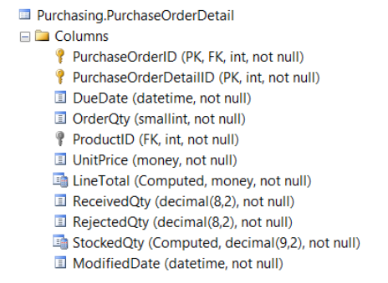

Several things to consider when working on your Data Diagrams.

* Only need to include PK, CPK and FK fields. To make it easier, we will leave out the rest of the fields.
* When drawing your lines from table to another table, connect to a specific field. Don’t just draw the line to any where on the table, the line needs to go to the specific field in the table that links the tables.
* On each side of the connecting line, draw the one or many symbol.

Part 2 (10 pts)

1. For the Sales Order Database page 724, explain in words the relationship of the tables.  
   For each line that connects two tables, you need to explain the relationship in each direction unless it involves a linking table. For example: For the Order and Customer table: An Order can only have one Customer and a Customer can have many Orders.  
     
   When you are describing the relationship of the Sales Orders Database tables, there is a linking table invovled. In my example below, Entertainer_Styles is the linking table.

Notice – I have three tables but I am only describing the relationship between Entertainers and Styles. I don’t mention the Entertainer_Styles that resolves a Many-to-Many relationship.

Each Entertainer can have many styles and each Style is held by many entertainers.

**Entertainer_Styles**

EntertainerID CPK

StyleID CPK

StyleStrength

**Styles**

StyleID PK

StyleName

**Entertainers**

Entertainer ID PK

EntStageName

EntSSN

EntStreetAddress

EntCity

Ent State

EntZipCode

EntPhoneNumber

EntEmailAddress

DateEntered

1. For the Employee, Skill, and Certification table below, identify the Primary Keys, Composite primary Key and Foreign Keys  
   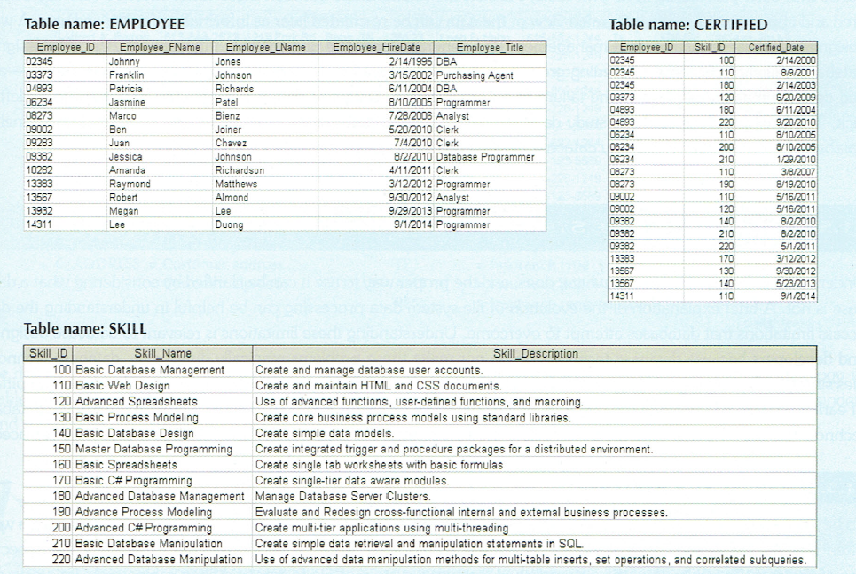
2. For the table above, explain in words the relationship of the tables
3. For the two tables, identify the Primary Keys, Composite primary Key and Foreign Keys.   
     
   Table: Course

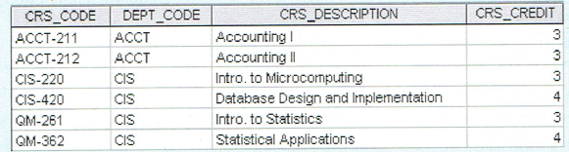  
  
Table: Class

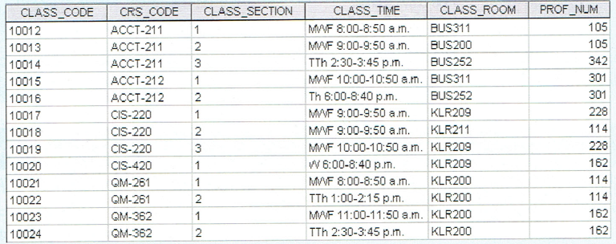

1. For the three tables, identify the Primary Keys, Composite primary Key and Foreign Keys.   
     
     
   Table: Student  
   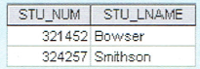  
     
   Table Enroll  
   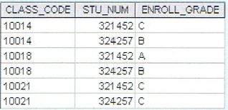  
     
   Table: Class  
   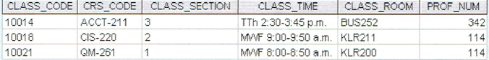
2. For the four tables, identify the Primary Keys, Composite primary Key and Foreign Keys.   
     
   Table: Customer  
   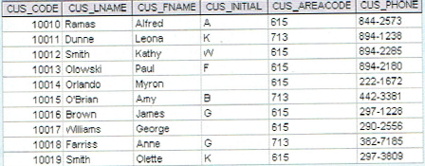  
     
   Table: Invoice Header  
   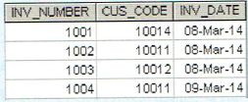  
     
   Table: Invoice Detail  
   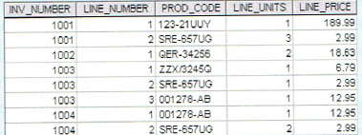  
     
   Table: Product  
   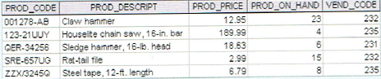
3. For the three tables on page 32 in our book, identify the Primary Keys, composite primary Key and Foreign Keys.
4. Put into words the relationship of the tables from question # 7.
5. For the three tables on page 50 in our book, identify the Primary Keys, composite primary Key and Foreign Keys.
6. Put into words the relationship of the tables from question #9.